Predicting the long-term impact of the emergence of an opposable digit or digits among or amidst the giant cephalopods on human mortality – a global perspective.

By James C. Collins[1]

# Introduction

The scientific community has long been transfixed by the giant cephalopods, including the giant squid[2], the colossal squid[3], and perhaps most mysteriously the great *kraken* of the northern Atlantic Ocean. Although no specimens of the *kraken* have been successfully taken alive, strong anecdotal evidence for its continued abundance is ample, in the form of some old ass paintings (Fig. 1) and by the fact of how “bad ass” it is. It has been widely assumed that a single *kraken* could easily consume approximately one full boat of sweaty Norwegians[4], in a single sitting, again referencing back to some old ass paintings.

Related studies have also demonstrated that the emergence of an opposable thumb makes essentially any species supremely more effective at destroying other plant and animal life. How do you fire a fifteen centimeter (15 cm) motor round into a slumbering coastal village without a thumb? Simply put, you do it with one of your other fingers. But the point is, you look totally stupid doing it because you have no thumb. Ever since the common gray wolf (*Canis lupus*) developed into the thumb-bearing common werewolf (*Canis lupus lunaris*), mortality rates among populations of rural European peasantry have sky-rocketed.[5]

The obvious question becomes, what would happen should a *kraken* ever develop an opposable thumb? Would feeding still be restricted to dragging down passing vessels into the icy depths of the ocean to consume all hands in a orgy of macabre blood-letting? Or would the *kraken* be able to aspire to even more horrible manners of slaughter and conquest, now equipped with a more effective grip? This paper aims to answer these important questions.

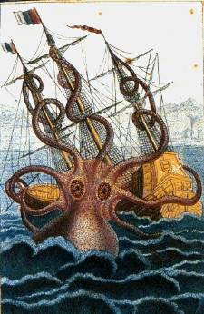

Figure 1-

A 1644 photo of a *kraken* getting all the fuck up in the business of some Norwegians who are about to be in a load of trouble.

Methods

A truly comprehensive survey of the damage a *kraken* with thumbs would pose to the world’s populations is, admittedly, hard to accurately quantify[6]. However, several important trends can lend perspective to our search for an answer to this important question.

First, global warming is kicking in. For reals this time. It’s just science. And this will mean that ocean levels will be rising, and as a result that more people will be within the easy reach of the greater *kraken* population*.* As humans become easier prey, the impact of the speculated *kraken*-with-thumbs or “*krathumbken*” for short, is likely to be increased.

Also, research suggests the a great majority of the world’s population, in all countires currently surveyed, lapses into a state of semi-consciousness for several hours, almost every night. This period of “sleep” affords the *krathumbken* an even greater opportunity to sneak into seaside home, and perhaps abduct the small and juicy infants to devour like popcorn before returning several nights later for a main course of adult victims. The risks that such “sleeping” entails greatly increase the risk of *krathumbken* related fatalities among all income groups across geographic locations.



Figure 2-

Although commonly considered a force for the greater good, the thumb (pictured left) can also be used to create great amounts of mischief, when on the wrong hands.

Results

If we take the current estimated global population of 7.142 billion people (7,142,000,000) and compare it with the estimated global *kraken* population of 10,000, population modeling shows us that the global human population will continue to grow incrementally for at least the next 200 hundred years, until leveling of somewhere around 9.0 billion people.

However, if we assume that the current *kraken* population is augmented by a *krathumbken* population of approximately 100 additional individuals per year, cross referenced with a “devouring rate” or approximately 40 people per day per *kraken* and a slightly increased “devouring rate” of 45 people per day per *krathumbken* due to increased metabolic demands, the mortality curve begins to reverse itself. As we can then assume that within six months, the *krathumbken* will acquire human machine guns and begin to kill not for food, but merely for sport, the trend of people dying really starts to take off, with approximately everyone on the planet dead with 32 years.

$γ_{h}= \frac{∆-γ_{k}∆}{n}* 45\left(365.25\right)*n$

*Where*

$γ$*is the annual mortality rate of humans ($γ_{h}$) given that of krakthumbkens ($γ_{k}$),*

$∆$*is the growth in the global population of krakthumbkens,*

*for n number of years.*

*Solving for n, we get $≠32.$*

This model should be qualified by the assumption that it does not presume that the *krathumbken* would be challenged by a new super-evolved species of super intelligent flying whales, who emerge from the depths to combat their ancient enemies. The *krathumbken* versus flying whale conflict would likely accelerate human die-off, as the two new dominant species of earth battle for supremacy, unmindful of the ruins of pathetic human civilization all around them. Then, of course, the *krathumbken* and the flying whales would team up at the last minute to deal with the new threat of nuclear powered death rhinoceroses (created by a mad scientist in a secret laboratory under Mount Kilimanjaro[7]) with titanium-reinforced, double-death tusks. A further scientific evaluation of that possibility could be the basis for further research by this author.

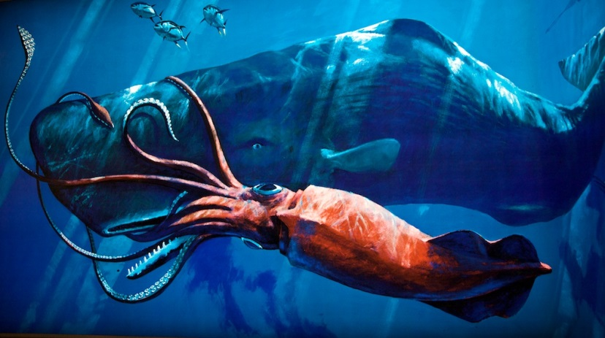

Figure 3 –

An ancient rivalry, forged in the midnight depths of the world’s oceans, is renewed in the skies over an awestruck planet.



Figure 4 –

Here is this line graph that I got off the internet; honestly I didn’t even look at it to see what it was charting.

# Discussion

Engaging with the issues of hypothetical creatures destroying mankind is an urgent and necessary exercise, and research into these crucial areas should be fully funded by the National Science Association, the Center for Disease Control, and the Audobon Society. Anyone who says otherwise is just a close-minded bigot, who probably has difficulty maintaining an erection.

## Acknowledgements

Thanks go out to Adrian Kense and Allison Miller for inspiring my dreams of hard-edged, data-based scientific research.

1. Professor Emeritus in Residence and Abroad, Alfred P. Giger Institute of Global Thinking at the University of Important Scholarly Research at Genoa, Scotland, USA.
2. *Archieteuthis japonica* as described in Pfeffer, 1912.
3. *Mesonychoteuthis hamiltoni* as described in Zwerthers, 1992.
4. By the standard Human Consumption Index (Andersuun, 1982) this amounts to 43 Peruvian school children, but only 16.2 American tourists, due in large part to a high fat content. It is presumed as sweaty Norwegians are the preferred food source of *krakens*, that should they be allowed a choice, they would gravitate toward Scandinavian people initially, but later generalizes to other persons.
5. *See* Busselbaum, et al (1982) *An examination of the modern European werewolf and interaction with Polish shacks, hovels and thatched huts*. The Bavarian Journal of Scientific Science and Learning , vol 2, Issue 14.
6. In the view of this author, as has been well-documented, the mainstream emphasis on “accuracy” within the fields of scientific study is increasingly over-valued. Science should, ideally, be conducted in a similar manner to the making of a blockbuster movie; loud noises, flashing lights, and appealing to the lowest common denominator among the American public

   Here is an image to illustrate the point:

   
7. The African based mad scientist market has been critically underdeveloped in popular culture, and is worth revisiting. Also possible are plague zebras, battle giraffes, and legions of mind-controlled telepathic meerkats. *See* J.Collins (2004) *New markets in underground lairs below the equator: Sub-Saharan Africa examined and evaluated*. Mad Scientist Home Journal, vol 14, episode 3.